***Virginia Junior Classical League***

*presents this*

Certificate of Excellence

*to*

Alex Smith

*of*

John Champe High School

*for*

*2nd Place in Mythology*

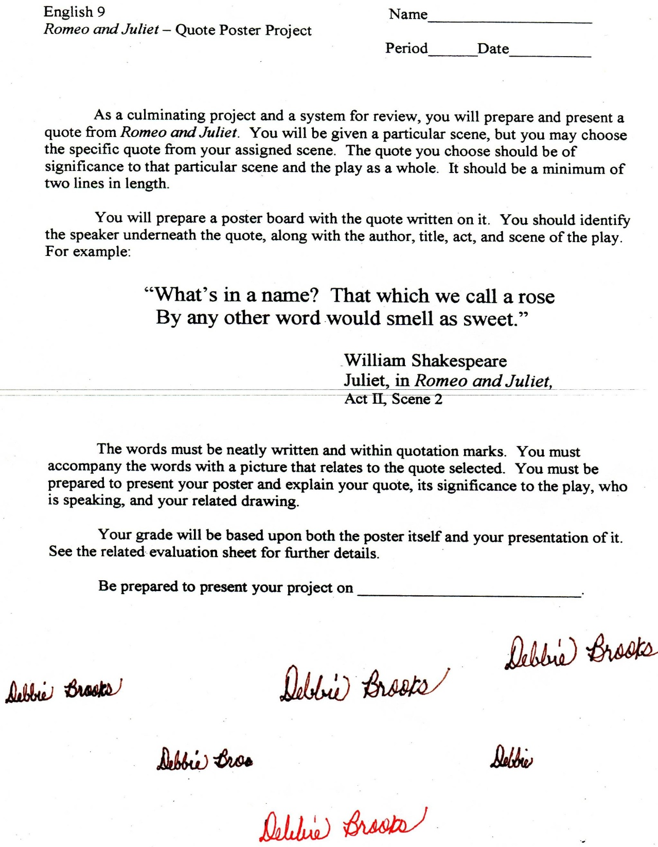

Microsoft Office Signature Line...

*a.d. viii Kal. Dec. MMDCCLXVII A.U.C. 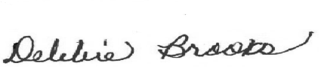*

***Virginia Junior Classical League***

*presents this*

Certificate of Excellence

*to*

Daniel Fisher

*of*

John Champe High School

*for*

*5th Place in Geography*

**

Microsoft Office Signature Line...

*a.d. viii Kal. Dec. MMDCCLXVII A.U.C. *

***Virginia Junior Classical League***

*presents this*

Certificate of Excellence

*to*

Do Lee

*of*

John Champe High School

*for*

*9th Place in Sight Latin*

**

Microsoft Office Signature Line...

*a.d. viii Kal. Dec. MMDCCLXVII A.U.C. *

***Virginia Junior Classical League***

*presents this*

Certificate of Excellence

*to*

Do Lee

*of*

John Champe High School

*for*

*10th Place in Life*

**

Microsoft Office Signature Line...

*a.d. viii Kal. Dec. MMDCCLXVII A.U.C. *